1) 先登入以下網址:- Please go to the following web link:-  http://www.loveideas.hk/vote/project_detail.aspx?appid=900784 | 2) 出現以下圖樣 This is what you will see.    然後按投票, then, click ‘Vote’,
3)按投票後, 會出現以下版面, and you will be presented with this screen.    如已註冊請填入已登記的電郵及密碼, 投票即可 If you have already set up a Voter Account, simply log in with your email address and password, your vote will then be recorded. | 4) 如未已註冊, 請按註冊 If you have not yet registered with a Voter Account, please click ‘sign up’.
5) 按註冊後, 會出現現這個版面 Once you have completed the sign up procedure, you will see this screen.  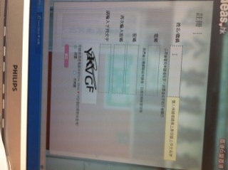 | 6) 填妥資料, 按確定 Complete the information as requested, and then click ‘Confirm’.  
7) 註冊已完成, 會出現這個版面 Once sign up procedure has been completed, you will see such screen.   | 8) 到你的登記email地址, 開啟email, 並按"連結"啟動戶口   Log on your registered email address. You should receive an email from love ideas love HK team, click on the link to activate your account.
9) 然後版面會出現多謝你的申請, 你已成功註冊香港仁ID You will see the screen as shown below, and thank ‘you’ for your support.   | 10) 最後, 將所有版面關掉, 從新再登入第1-3步驟, 即完成投票  Please close ALL web links, and start from steps 1 to 3, and complete the voting process.  11) 先登入以下網址:- Step 1:Go to the following web link:-http://www.loveideas.hk/vote/project_detail.aspx?appid=900784
12) 出現以下圖樣 Step 2: This is what you will see.  然後按投票, then, click ‘Vote’, | 13)按投票後, 會出現以下版面, Step 3: and you will be presented with this screen.  填入你剛才登記的電郵及密碼, 然後按投票即完成Click Log in, and then log in with your email address and password, your vote will then be recorded.
謝謝您們！Thank you.

